**Name :S.Prakul**

**192210073**

**EXP 1:Demonstrate virtualization by Installing Type -2 Hypervisor in your device, create and configure VM image with a Host Operating system (Either Windows/Linux)**

**Step 1:**

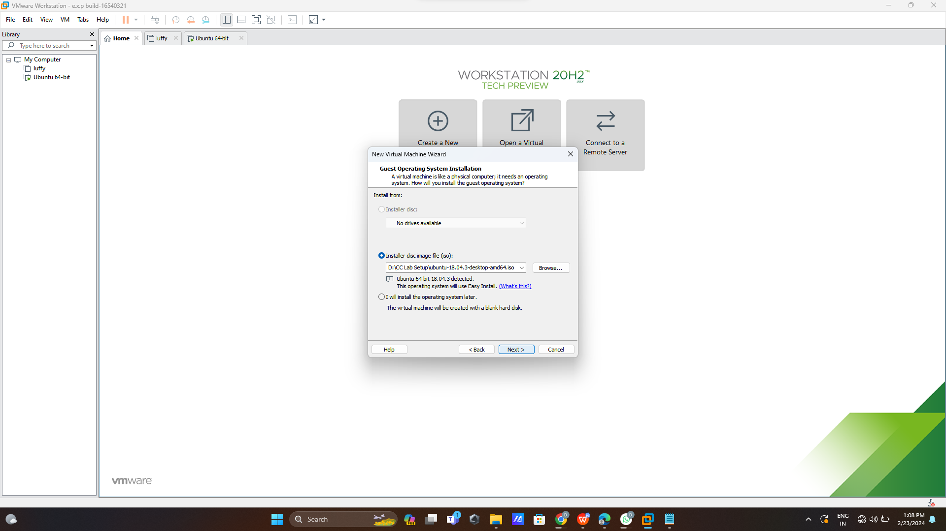

**Step 2:**

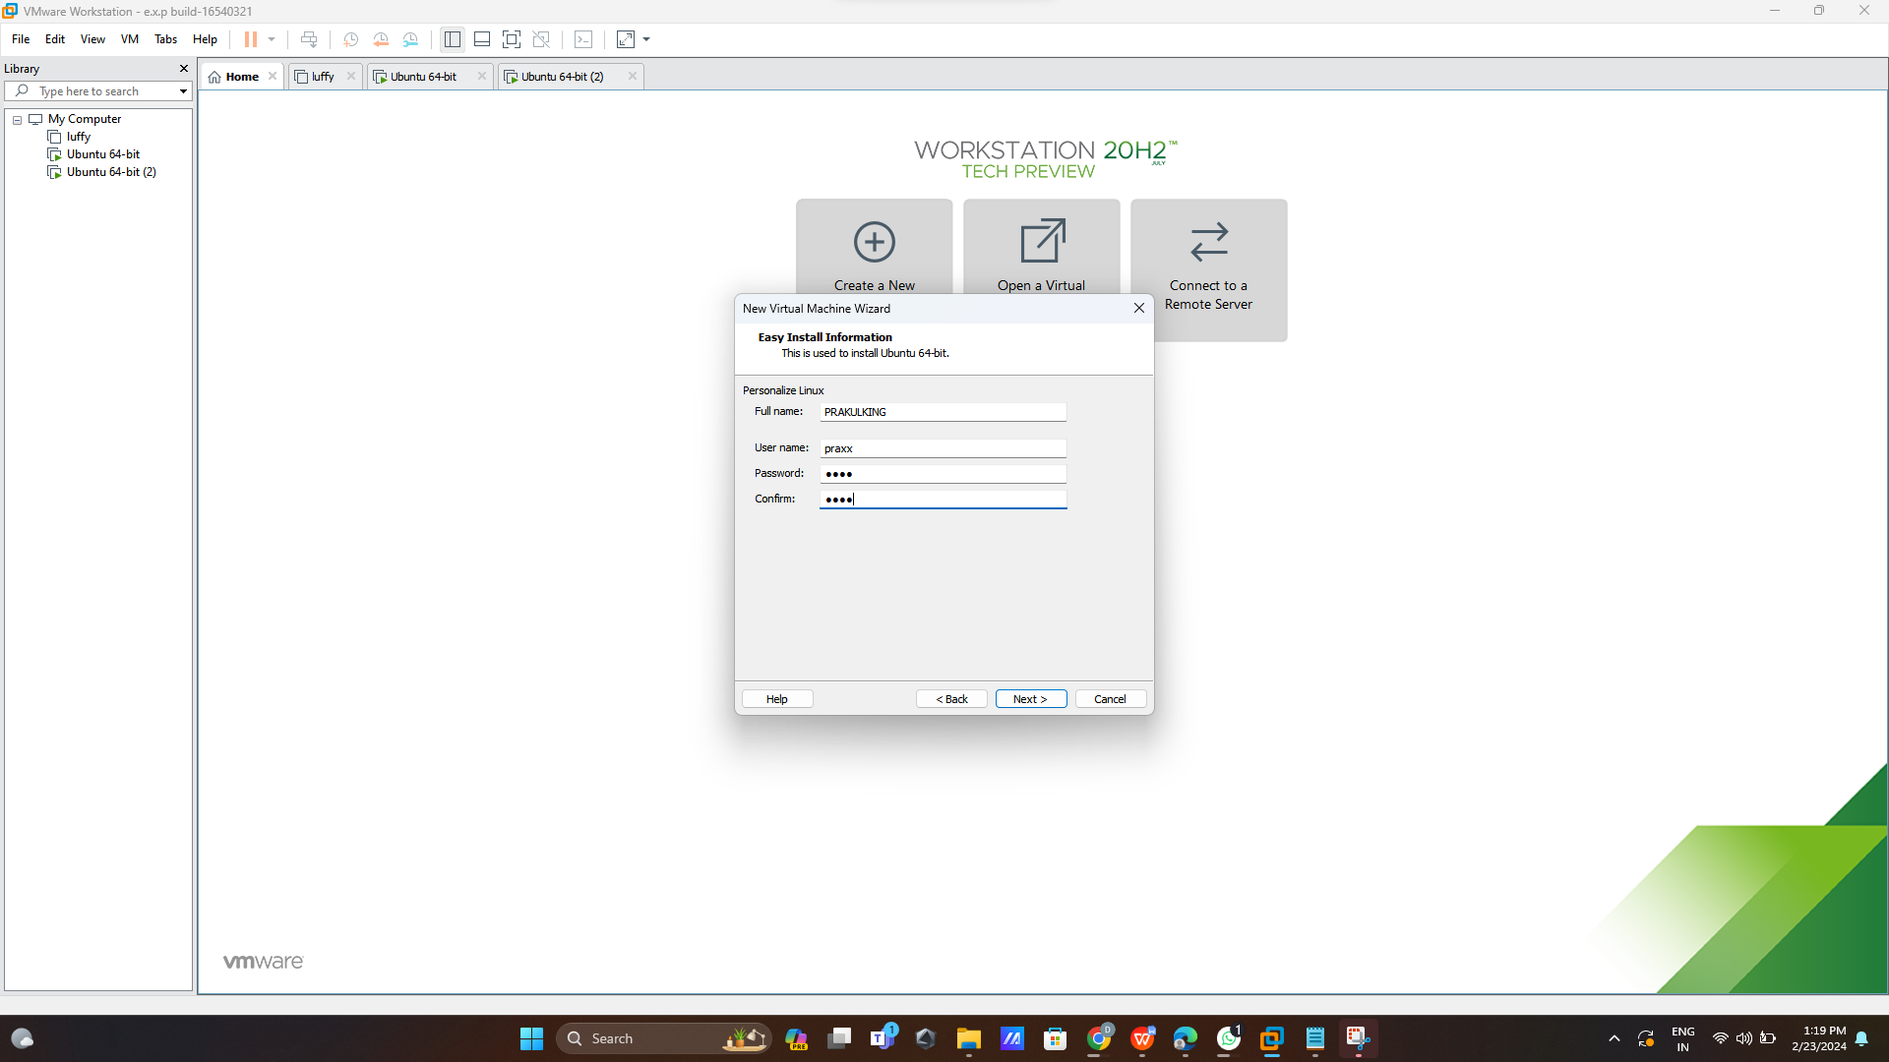

**Step 3:**

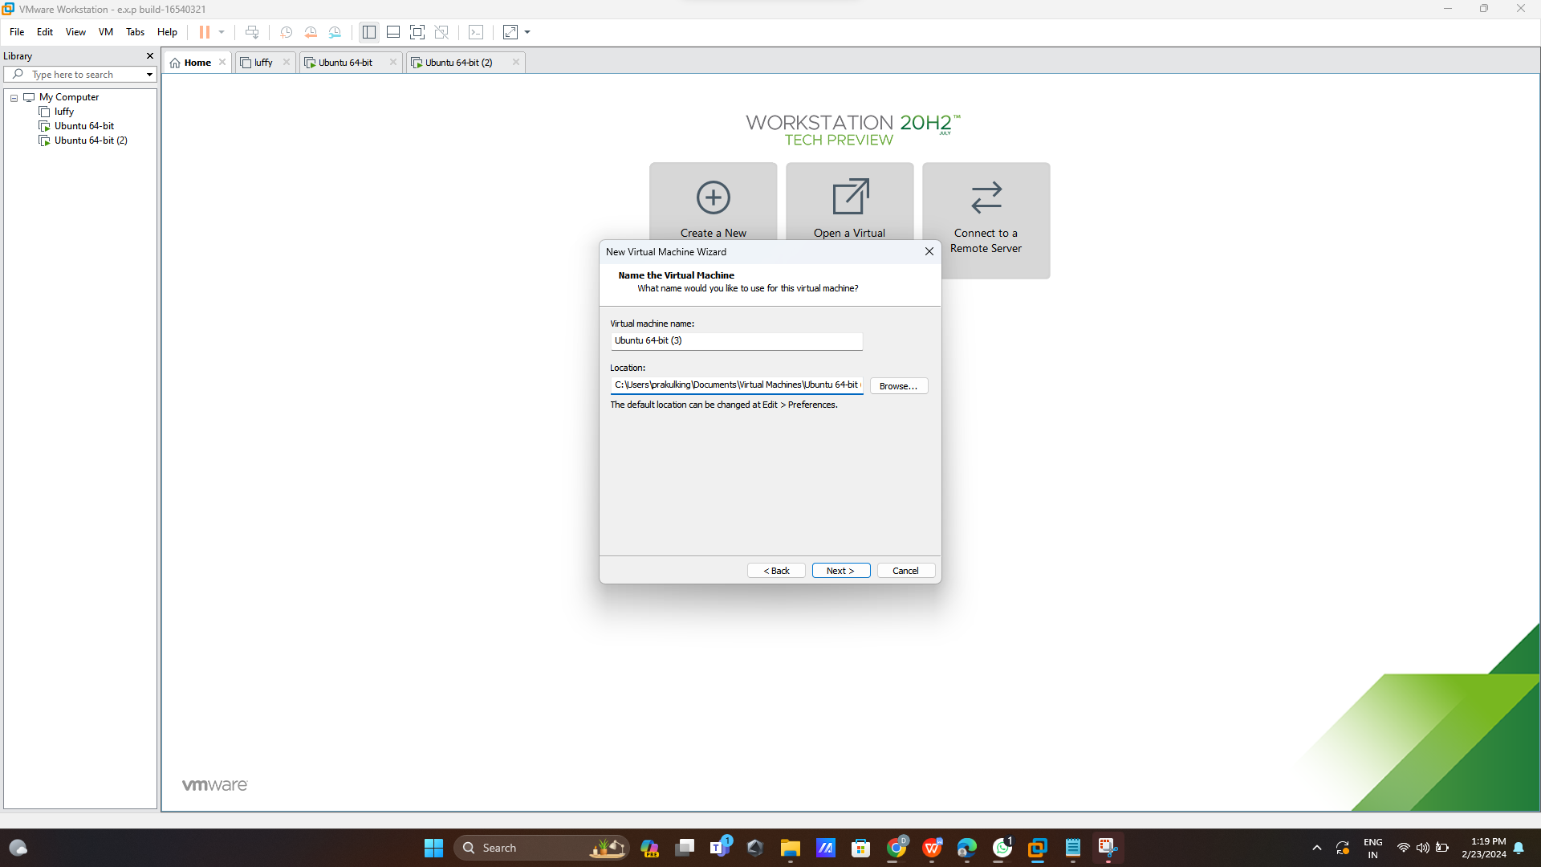

**Step 4:**

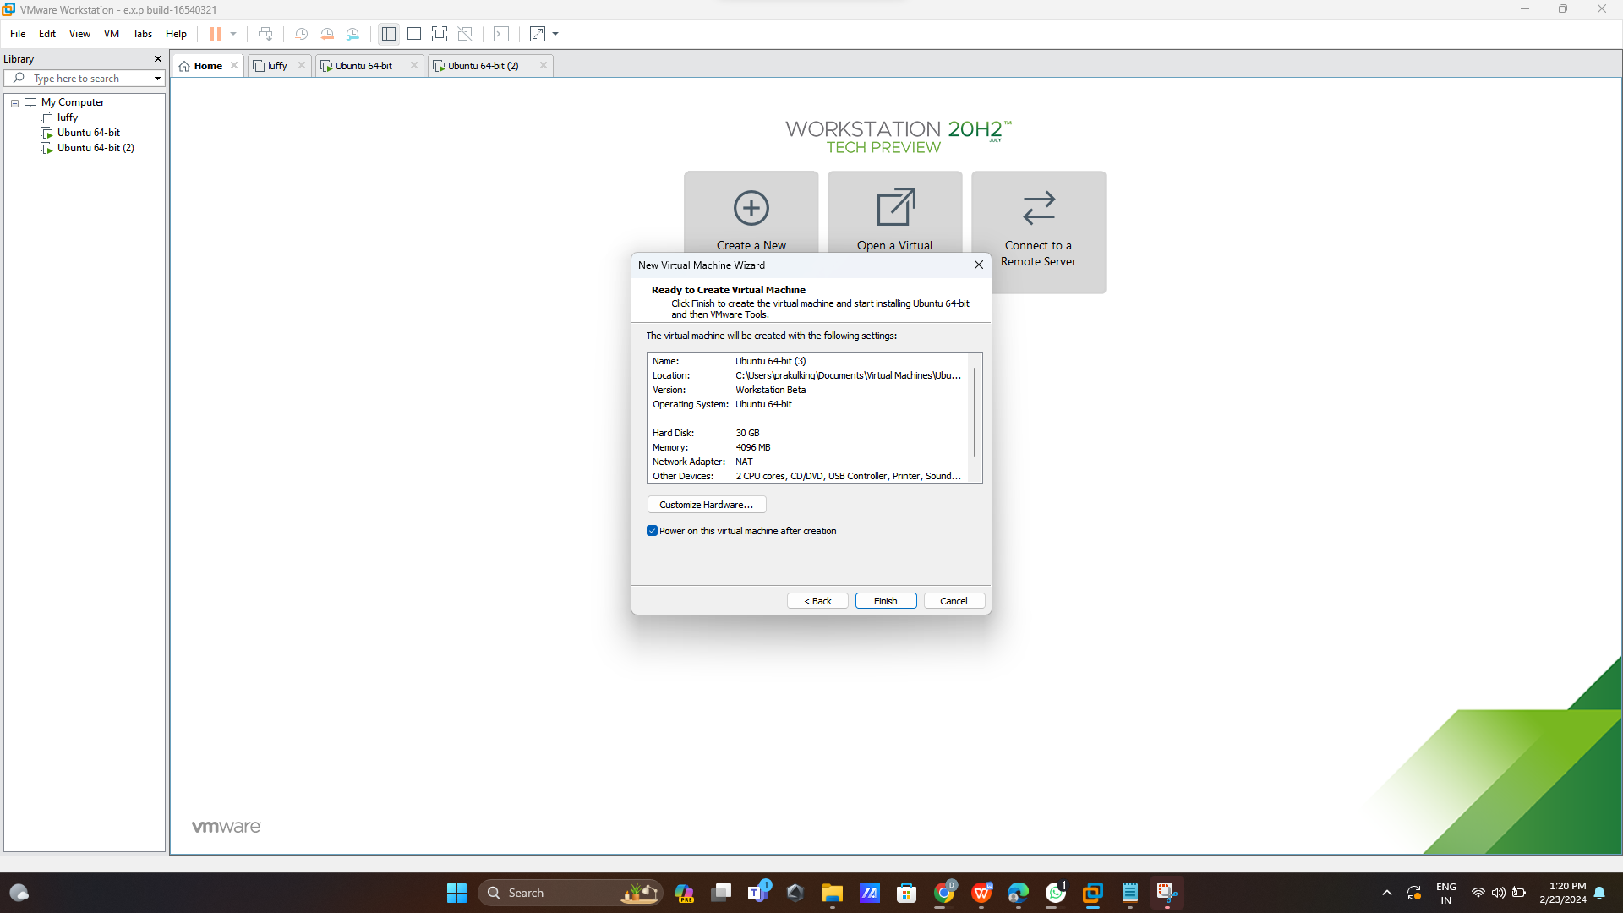

**Step 5:**

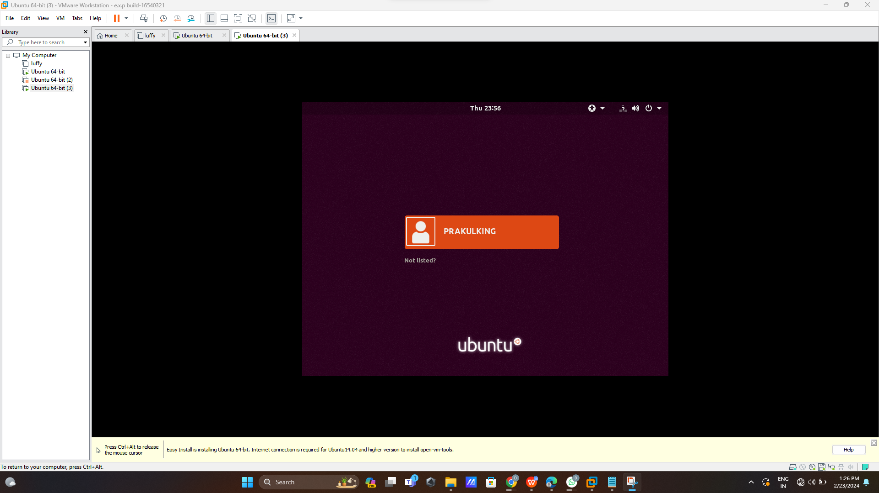

**Step 6:**

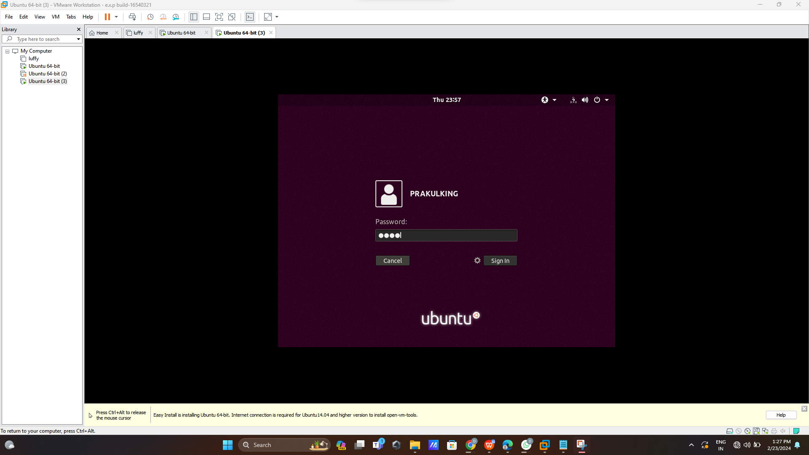

**Step 7:**

